

***Data Structure and Algorithm (Lab)***

***Assignment – 4***

**Name:**

Ali Maqsood.

**Roll no:**

SU92-BSAIM-F23-050.

**Department:**

Software Engineering Department.

**Program:**

Artificial Intelligence.

**Section:**

BSAI-3A

***Selection Sort***

**Question # 1:**

1. **Basic Selection Sort Implementation:**Implement a function to perform selection sort on a given list of integers.  
   Example Input: [29, 10, 14, 37, 14]  
   Expected Output: [10, 14, 14, 29, 37]

**Code:**

def task1(arr1):

    print(f"Input Array: {arr1}.")

    for i in range(len(arr1)-1):

        small=i

        for j in range(i+1,len(arr1)):

            if arr1[j]<arr1[small]:

                small=j

        arr1[i],arr1[small]=arr1[small],arr1[i]

    print(f"Output Array: {arr1}.")

task1([29, 10, 14, 37, 14])

**Output:**



**Question # 2:**

**Sorting Strings Using Selection Sort:**Write a program to sort a list of strings alphabetically using selection sort.  
Example Input: ["apple", "orange", "banana", "kiwi"]  
Expected Output: ["apple", "banana", "kiwi", "orange"]

**Code:**

def task2(arr2):

    print(f"Input Array: {arr2}.")

    for i in range(len(arr2)-1):

        small=i

        for j in range(i+1,len(arr2)):

            if arr2[j]<arr2[small]:

                small=j

        arr2[i],arr2[small]=arr2[small],arr2[i]

    print(f"Output Array: {arr2}.")

task2(["apple","orange","banana","kiwi"])

**Output:**

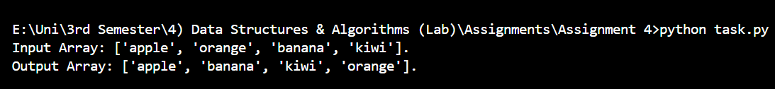

**Question # 3:**

1. **Descending Order Selection Sort:**Modify the selection sort algorithm to sort the list of integers in descending order.  
   Example Input: [12, 4, 45, 23, 18]  
   Expected Output: [45, 23, 18, 12, 4]

**Code:**

def task3(arr3):

    print(f"Input Array: {arr3}.")

    for i in range(len(arr3)-1):

        small=i

        for j in range(i+1,len(arr3)):

            if arr3[j]<arr3[small]:

                small=j

        arr3[i],arr3[small]=arr3[small],arr3[i]

    arr3.reverse()

    print(f"Output Array: {arr3}.")

task3([12, 4, 45, 23, 18])

**Output:**



**Question # 4:**

1. **Selection Sort with Custom Comparators:**Implement a selection sort that can handle custom comparator functions to sort a list.  
   Example: Sort based on the second character of each string.  
   Example Input: ["cat", "bat", "apple", "car"]  
   Expected Output: ["bat", "cat", "car", "apple"]

**Code:**

def task4(arr4):

    print(f"Input Array: {arr4}.")

    for i in range(len(arr4)-1):

        small=i

        for j in range(i+1,len(arr4)):

            if arr4[j][1]<arr4[small][1]:

                small=j

        arr4[i],arr4[small]=arr4[small],arr4[i]

    print(f"Output Array: {arr4}.")

task4(["cat", "bat", "apple", "car"])

**Output:**



**Question # 5:**

1. **Count the Number of Swaps:**Modify the selection sort algorithm to count the total number of swaps performed during sorting. Return the sorted list along with the count of swaps.

**Code:**

def task5(arr5):

    print(f"Input Array: {arr5}.")

    swaps=0

    for i in range(len(arr5)-1):

        small=i

        for j in range(i+1,len(arr5)):

            if arr5[j]<arr5[small]:

                small=j

        arr5[i],arr5[small]=arr5[small],arr5[i]

        swaps+=1

    print(f"Output Array: {arr5}.")

    print(f"Total Swaps Taken: {swaps}.")

task5([29, 10, 14, 37, 14])

**Output:**

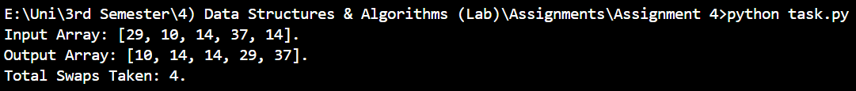

***Insertion Sort***

**Question # 6:**

1. **Basic Insertion Sort Implementation:**Implement insertion sort to sort a list of integers.  
   Example Input: [12, 11, 13, 5, 6]  
   Expected Output: [5, 6, 11, 12, 13]

**Code:**

def task6(arr):

    print(f"Input Array: {arr}.")

    for i in range(1,len(arr)):

        key=arr[i]

        j=i-1

        while j >= 0 and key<arr[j]:

            arr[j+1]=arr[j]

            j-=1

        arr[j + 1]=key

    print(f"Output Array: {arr}.")

task6([12, 11, 13, 5, 6])

**Output:**



**Question # 7:**

1. **Insertion Sort for Linked Lists:**Implement insertion sort to sort the elements of a singly linked list in ascending order.

**Code:**

def task7(arr):

    print("Not Attempted.")

    pass

task7()

**Output:**



**Question # 8:**

1. **Binary Insertion Sort Optimization:**Implement insertion sort using binary search to find the appropriate position for inserting each element, thereby reducing the number of comparisons.

**Code:**

def task8(arr):

    print("Not Attempted.")

    pass

task8("True")

**Output:**



**Question # 9:**

1. **Sort a List of Tuples Using Insertion Sort:**Write a program that sorts a list of tuples based on the second element of each tuple using insertion sort.  
   Example Input: [(1, 3), (4, 1), (2, 2)]  
   Expected Output: [(4, 1), (2, 2), (1, 3)]

**Code:**

def task9(arr):

    print(f"Input Array: {arr}.")

    for i in range(1,len(arr)):

        key=arr[i]

        j=i-1

        while j >= 0 and key<arr[j]:

            arr[j+1]=arr[j]

            j-=1

        arr[j + 1]=key

    print(f"Output Array: {arr}.")

task9([(1,3),(4,1),(2,2)])

**Output:**



**Question # 10:**

1. **Insertion Sort with Reverse Sorting:**Modify the insertion sort to sort the given list of integers in descending order.  
   Example Input: [5, 2, 9, 1, 5, 6]  
   Expected Output: [9, 6, 5, 5, 2, 1]

**Code:**

def task10(arr):

    print(f"Input Array: {arr}.")

    for i in range(1,len(arr)):

        key=arr[i]

        j=i-1

        while j >= 0 and key<arr[j]:

            arr[j+1]=arr[j]

            j-=1

        arr[j + 1]=key

    arr.reverse()

    print(f"Output Array: {arr}.")

task10([12, 11, 13, 5, 6])

**Output:**



**Question # 11:**

1. **Count Shifts During Insertion Sort:**Track andprint the number of shifts performed while sorting the list using insertion sort.

**Code:**

def task11(arr):

    print(f"Input Array: {arr}.")

    counter=0

    for i in range(1,len(arr)):

        key=arr[i]

        j=i-1

        while j >= 0 and key<arr[j]:

            counter+=1

            arr[j+1]=arr[j]

            j-=1

        arr[j + 1]=key

    print(f"Output Array: {arr}.")

    print(f"Total Swaps Taken: {counter}.")

task11([12, 11, 13, 5, 6])

**Output:**

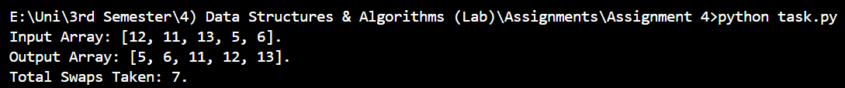

**Question # 12:**

1. Insertion Sort in Matrix Sorting:  
   Sort each row of a 2D matrix using insertion sort.

Example Input:

[[5, 1, 4],

[3, 9, 2],

[8, 6, 7]]

Expected Output:

[[1, 4, 5],

[2, 3, 9],

[6, 7, 8]]

**Code:**

def task12(matrix):

    print(f"Input Matrix: {matrix}.")

    for r in matrix:

        for i in range(1, len(r)):

            key=r[i]

            j=i - 1

            while j >= 0 and key < r[j]:

                r[j + 1]=r[j]

                j-=1

            r[j + 1] = key

    print(f"Output Matrix: {matrix}.")

task12([[5, 1, 4],[3, 9, 2],[8, 6, 7]])

**Output:**

